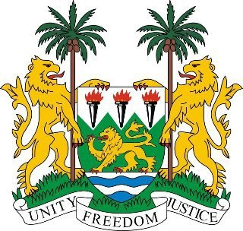
SIERRA LEONE
20th Session of the Universal Periodic Review

SAN MARINO

Statement by Ambassador Yvette Stevens

29 October 2014

Mr President,

Sierra Leone welcomes the delegation of San Marino and thanks them for the presentation of the national report.

My delegation commends San Marino’s efforts to promote and protect human rights in the country in spite of the international economic crisis which has impacted on their implementation strategies. Notable steps include measures taken to address the issues of Fair Trial, the Death Penalty, Violence against Women and Domestic Violence. My delegation notes, with interest, that San Marino is the third country in the world to abolish the death penalty.

Sierra Leone appreciates the efforts made by the Republic of San Marino to domesticate International Human Rights Instruments and commends it for the measures it has taken to ensure Freedom of Religion or Belief. We acknowledge the efforts of San Marino to sign ratify or accede to more Human Rights instruments after the first UPR review.

Sierra Leone would like to make the following recommendations for consideration by San Marino:

- Consider ratifying the CPED and ICRMW.
- Submit its national reports to the relevant UN treaty bodies.
- Further strengthen existing mechanisms aimed at safeguarding the rights of women, especially with regard to protection against violence.
- To intensify ongoing efforts to adjust domestic legislation to International Standards;

In conclusion, Sierra Leone lauds San Marino’s financial contributions to the work of the Office of the High Commissioner for Human Rights in 2011 and 2013. Sierra Leone wishes San Marino every success in the completion of this UPR process.

Mr President, I thank you.

